|  |  |
| --- | --- |
| Monday, Aug 06, 2012 | Navin Hotwani |
| SAP – Life Insurance – CM | Insurance Domain – Overview (I) |

## Legal principles of Insurance

1. Indemnity: The insurance company indemnifies, or compensates, the insured in the case of certain losses only up to the insured's interest.
2. Insurable Interest: A person has an insurable interest in something when loss-of or damage-to that thing would cause the person to suffer a financial loss or other kind of loss.
3. Utmost Good Faith: The insured and the insurer are bound by a [good faith](http://en.wikipedia.org/wiki/Good_faith) bond of honesty and fairness. Material facts must be disclosed.
4. Proximate cause (Peril): The cause of loss (the peril) must be covered under the insuring agreement of the policy

## PARTIES TO INSURED

|  |  |
| --- | --- |
| INSURED | The person / policyholder of the insurance |
| INSURER | The insurance company or the entity which bears the risk |
| CLAIMANT | Person or entity who makes the claim |
| THIRD PARTY ADMINISTRATORS | Organization which processes claims and certain administrative services to the insurance company |
| REGULATORS | Regulatory Authority (e.g. IRDA – India, NAIC-USA, FSA-UK) |
| PRODUCERS | Responsible for generation of business (American business context) |
| Actuary | Statistician/Mathematician who collates data and constructs Insurance rate tables |
| UNDERWRITER | Who evaluates the prospective customer’s risk and decides the policy details (premium, benefit amount). |
| AGENT/BROKER | Agent : Who sells the insurance policy on behalf of the company / Brokers : buys on behalf of the customer |
| INVESTIGATOR | Investigates and ascertains the risk and submits the report to the underwriter |
| ADJUSTER | Negotiates the claim settlement amount between the claimant and company |
| SURVEYOR | Evaluates the damage/loss caused due the event |
| THIRD PARTY VENDORS | Service providers, Garages, Towing service, Hospitals etc |
| RECOVERY SPECIALISTS | Recovery of salvage (prominent in Marine Insurance) |

* Subrogation: Subrogation refers to the process an insurance company uses to seek reimbursement from the responsible party for a claim it has already paid. Subrogation is the right for an insurer to pursue a third party that caused an insurance loss to the insured. This is done as a means of recovering the amount of the claim paid to the insured for the loss.
* Deductible: To make sure the insured is liable and not to make him lenient (e.g. 1.5% of the claim amount or fixed charges). Amount deducted from your claim. For example, if you get into an accident and your medical expenses are $2,000 and your deductible is $300, then you would have to pay the $300 out-of-pocket first before the insurance company paid the remaining $1,700. However, if your accident only resulted in $300 in medical expenses, then you would pay the $300 deductible and the insurance company would pay nothing.
* Exclusion: Exclusion is a provision within an insurance policy that eliminates coverage for certain acts, property, types of damage or locations.
* Limit: Ceiling amount fixed to be paid per instance (claim, person).
* Co-Pay: A type of insurance policy where the insured pays a specified amount of out-of-pocket expenses for health-care services such as doctor visits and prescriptions drugs at the time the service is rendered, with the insurer paying the remaining costs. However, unlike coinsurance, where the insured is required to pay a certain percentage of the covered costs, co-pay plans require the insured to pay a specified dollar amount. Practiced in Health Insurance.
* Co-Insurance: An insurance arrangement wherein multiple insurance companies come together to insure a single property. The insured enters into a contract with each of the insurance company and no single insurance company is liable to pay more than the share it has agreed to cover upon. In case of any single insurance company going insolvent, the other insurance companies do not hold any liability to pay for the share of insolvent insurance company.
* Excess Insurance: Excess insurance is a type of insurance primarily for Liability exposure where in the excess insurer provides the limits over and above the limit offered by the primary insurance. This insurance policy will only pay, if the primary insurance admits and pays for the claim to the extent covered in the primary insurance policy.
* Underinsurance: Inadequate insurance coverage by the holder of a policy. In the event of a claim, underinsurance may result in economic losses to the policy holder, since the claim would exceed the maximum amount that can be paid out by the insurance policy. While underinsurance may result in lower premiums paid by the policy holder, the loss arising from a claim may far exceed any marginal savings in insurance premiums. As an example you may insure your house at $80,000 when the total value of the house actually comes to $100,000. At the time of partial loss, your insurer will pay only a proportion of $80,000 while you have to dig into your savings to cover the remaining portion of the loss.
* Umbrella Insurance: Extra liability insurance coverage that goes beyond the limits of the insured's home, auto or watercraft insurance. It provides an additional layer of security to those who are at risk for being sued for damages to other people's property or injuries caused to others in an accident. It also protects against libel, vandalism, slander and invasion of privacy. An umbrella insurance policy is very helpful when the insurance owner is sued and the dollar limit of the original policy has been exhausted. The added coverage provided by liability insurance is most useful to individuals who own a lot of assets or very expensive assets and are at significant risk of being sued.

|  |  |
| --- | --- |
| AGENT/CAPTIVE AGENT | Captive agents represent a single insurance company and are required to only do business with that one company. |
| BROKER/INDEPENDENT AGENT | Independent agents represent multiple companies and work on behalf of the client (not the insurance company) to find the most appropriate policy. |

* Underwriting: It is the process of evaluating the risk to be insured. This is done by the insurer when determining how likely it is that the loss will occur, how much the loss could be and then using this information to determine how much you should pay to insure against the risk.
* Producer: An insurance Producer means any person (individual, corporation, association, partnership, limited liability company, limited liability partnership, or other legal entity) who or which is licensed to solicit, negotiate, or sell insurance.

Types of Insurance

|  |  |
| --- | --- |
| Life Insurance | * + Term Insurance   + Whole Life Insurance   + Universal Life Insurance (TERM + WHOLE) |
| Pension/Annuities | * + Deferred Annuities   + Etc. |
| General Insurance | * + Property & Casualty   + Liability Insurance   + Specialty Insurance |
| Health Insurance |  |

|  |  |
| --- | --- |
| Tuesday, Aug 07, 2012 | Navin Hotwani |
| SAP – Life Insurance – CM | Insurance Domain – Overview (II) |

Policy Issuance: The Quote version is maintained to track the changes in quote.

Reinstatement: reinstatement allows a previously terminated policy to resume active coverage. Depending on the circumstance of the termination, such as failure to pay the premium, the insured person may be required to compensate the insurer before reinstatement occurs. Reinstating the policy would provide the insured with all the benefits of their original plan. In case of non-payment, the insured may be required to provide evidence of eligibility, such as taking a medical examination for life insurance. Additionally, the person might have to pay the insurance company for the missed premium dates. Reinstatement can be done for the limit of insured amount.

e.g., Jan-Dec: Existing Policy with limit of INR 1 Lakh. In June claim has been made for the entire amount. To continue the insurance policy, the insured can offer to pay additional premium to reinstatement the policy amount. But the policy would end of Dec (as decided in the original policy)

Claims Management:

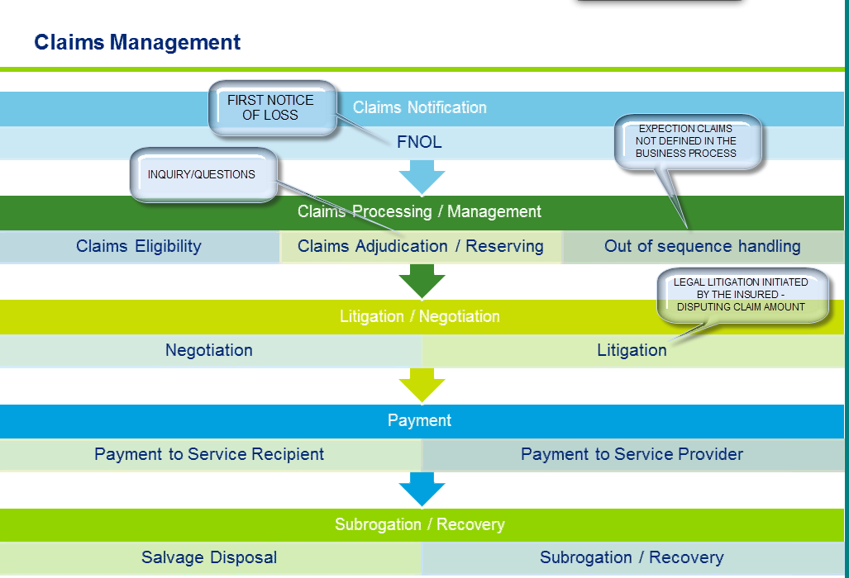

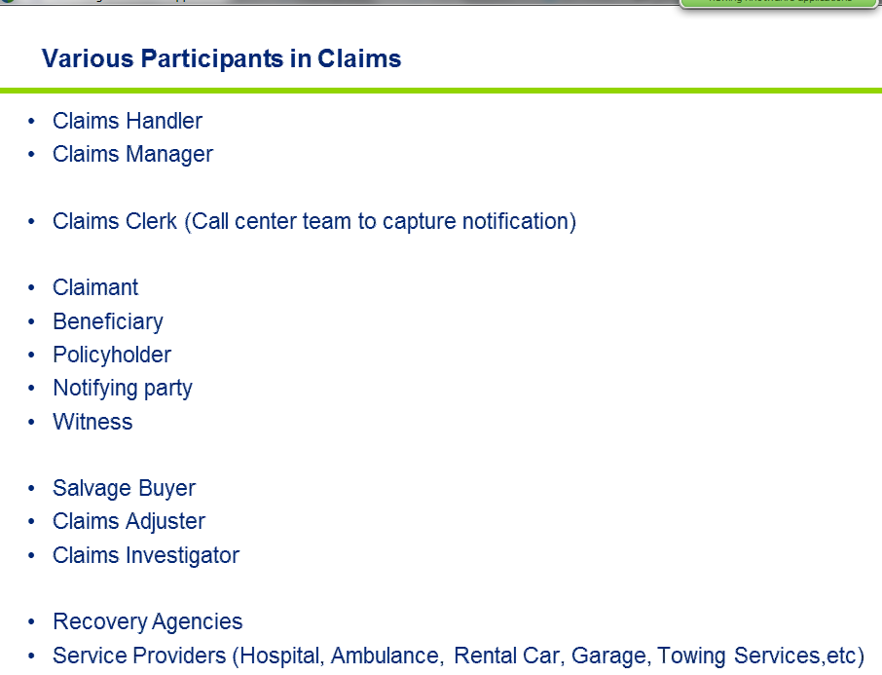

Claims Investigator: Independent investigator who ascertains the facts related to the claim incident and reports to the company. He is not an employee of insurance company.

Scenarios:

🡪 HSA – HEALTH SPENDING ACCOUNT (CANADA)

REF: <http://www.pac.bluecross.ca/corp/howbenefitswork/faq/hsafaq.aspx>

🡪 COB – COORDINATION OF BENEFITS

COB describes coordination of Benefits for the insured among multiple policies. Arrangement in health insurance to discourage multiple payment for the same claim under two or more policies. When two or more group health insurance plans cover the insured and dependents, one plan becomes the *primary*plan and the other plan(s) the *secondary*plan(s). For example, two working spouses have health insurance at their respective places of employment. If one spouse becomes ill, his/her policy at work would become the primary plan. Medical expenses not covered under the primary plan would be covered under the secondary plan of the other spouse.

